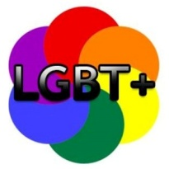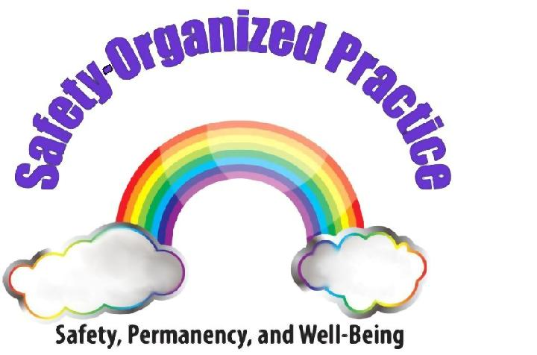

Solution Focused Questions for LGBT+ Youth’s Cultural Identity
Exception: Surfacing exceptions/solutions to the problem that the family has already done in the past.
Preferred Future: Having them think about a more positive future and identify
ways to get there
Coping: Looking for ways they’ve managed the difficulties or problem
Positioning: Getting people thinking from another person’s perspective
Scaling: Taking something that could be yes/no and getting more information and helps to identify next steps to move things in a positive direction

Example Questions
- “When disclosing your LGBT+ identity, tell me about some positive feelings or experiences you may have had?”
- “Who have you told about your gender/sexual identity? How did you decide to share your identity with them?”
- “Who are the people in your support network who have most supported your identity? What do these people do to let you know that they support you?”
- What makes you feel like your best self? How would others notice that you are at your best?”
- “Can you tell me more about what gender queer or _______ means to you? Can you explain to me how you see yourself?”
- “What kind of clothes do you prefer to wear? Do you feel like a boy, a girl, or do you believe gender identity is fluid?”
- “How have the conflicts and challenges you’ve faced with your LGBT+ identity affected you?”
- “What are your biggest worries today around your parents/caregivers finding out you are gay and/or gender non-conforming? Is there anyone you feel safe with that I can talk to about supporting you so you feel safe?”
- “Are you in an intimate relationship right now? Can you tell me a little about this person and what you like best about them? If your boyfriend/girlfriend/partner were here right now, what would they say they like best about you? What is something that makes them proud of you?”
- “On a scale from 1-10, 10-being “I look and feel at ease and comfortable in the clothes I wear,” and 1 “I hate how I look and feel in my clothing,” where would you scale yourself? What gets you to that number? What do you think needs to change for you to move up one?”
- “Do you have any friends or relatives you feel connected to in the LGBT+Q community? How have they supported you?” Have you ever joined a support group at school, in the community or visited The LGBT+ Community Center, The Hillcrest Youth Center or LGBT+ Resource Center?
- “Who are some of your role models? What do you like best about them? If they were here right now, what advice would they give you to work through these challenges?”
- “What would you tell another kid in your situation? What would you tell your 10yr old self? Or your 5yr old self?”

