Safety, Permanency and Well-Being For LGBT+ Foster Youth &

Social Worker Practice Tips

“Transition is an intervention, not a decision.”
- Darlene Tando, LCSW

LGBT+ Youth in the Foster Care System:

Bill SB 731 was amended so that the foster care system “would require foster children and non-minor dependents in out-of-home-care to be placed according to their gender identity, regardless of the gender or sex listed in their court or child welfare records.

Transgender and gender non-conforming youth often face serious physical, emotional, and sexual abuse in group homes, detention centers, and correctional institutions. Because staff members are often unsure of how to provide respectful and supportive services to these youth, they may unknowingly subject them to situations that are discriminatory and harmful.

FAQ’s

What does Transgender mean?

Transgender is a term often used to describe an individual whose gender identity does not necessarily match the sex assigned to them at birth.

What is Sexual Orientation?

Sexual orientation refers to an individual’s emotional, romantic, or sexual feelings toward other people.

What is gender identity?

Gender identity is the term that is used to describe a person’s deeply held personal, internal sense of being male, female, some of both, or maybe even neither. A person’s gender identity may not always correspond to their assigned biological sex.

At what age is gender identity typically formed?

A lot of experts in the field believe that awareness of gender identity is experienced in infancy, solidifies around age three, and then gets reinforced in adolescence through how we teach youth about who boys and girls are expected to be.

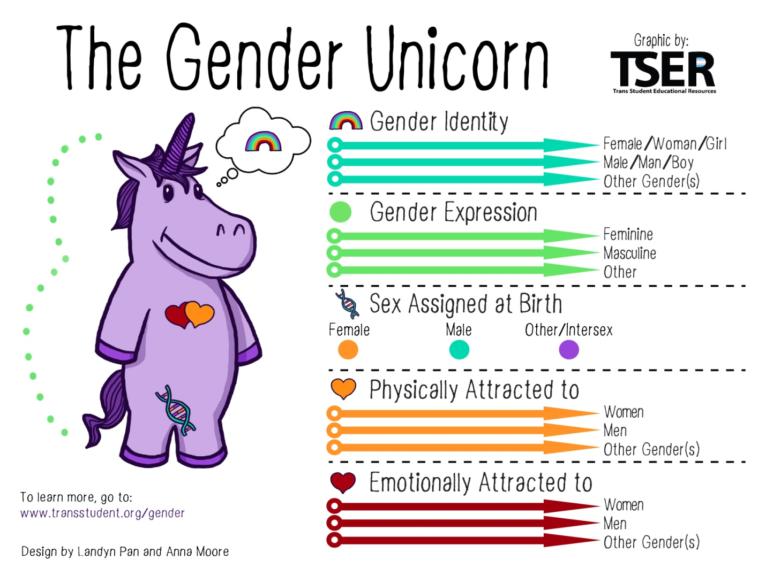

Definitions:
Gender Identity: One’s internal sense of being male, female, neither of these, both, or another gender(s). Everyone has a gender identity, including you. For transgender people, their sex assigned at birth and their own internal sense of gender identity are not the same. Female, woman, and girl and male, man, and boy are also NOT necessarily linked to each other but are just six common gender identities.
Gender Expression/Presentation: The physical manifestation of one’s gender identity through clothing, hairstyle, voice, body shape, etc. Most transgender people seek to make their gender expression (how they look) match their gender identity (who they are), rather than their sex assigned at birth.
Sex Assigned at Birth: The assignment and classification of people as male, female, intersex, or another sex based on a combination of anatomy, hormones, and chromosomes. It is important we don’t simply use “sex” because of the vagueness of the definition of sex and its place in transphobia. Chromosomes are frequently used to determine sex from prenatal karyotyping (although not as often as genitalia). Chromosomes do not determine genitalia.
Sexually Attracted To: Sexual Orientation; It is important to note that sexual and romantic/emotional attraction can be from a variety of factors including but not limited to gender identity, gender expression/presentation, and sex assigned at birth.
Romantically/Emotionally Attracted To: Romantic/emotional orientation; It is important to note that sexual and romantic/emotional attraction can be from a variety of factors including but not limited to gender identity, gender expression/presentation, and sex assigned at birth.

The Transgender Child

- Pre-puberty transition is social and not surgically related (appearance, names, pronouns, etc.)

- At the onset of puberty some children begin “hormone blockers,” which prevents puberty from beginning in the undesired gender. The blockers, originally used for children experiencing precocious puberty, have been shown to be physically harmless and are completely reversible.

- If the child has already progressed through the undesired puberty, the child may or may not have body dysphoria, and desire surgeries to reverse unwanted pubertal development (breast removal, hair removal, etc)

- Some adolescents choose to use cross-sex hormones, so that they may go through puberty in their affirmed gender. This can cause irreversible changes and infertility, however many physicians, parents, and youth feel it is necessary to administer cross-hormones to avoid suicide, self-harm, and other psychological issues.

- When dealing with a minor who presents as transgender or gender questioning/fluid you must consider whether or not the minor has parental support or parental knowledge of their transgender status.

Best Practices for a Supportive & Inclusive Atmosphere for Trans Youth

(Adapted from CWLA Best Practices Guidelines, Serving LGBT+ Youth in Out of Home Care)

- Create and maintain an inclusive culture and environment within the organization

- Adopt a policy that prohibits discrimination based on perceived gender or sexual orientation and display posters throughout the facility.
- Create opportunities for dialogue and promptly intervene when youth or adults act disrespectfully.

- Personnel should nurture the development of permanent adult life long family connections within youth’s life

- Parental support is crucial to emotional well being of transgender youth, but not always offered. Provide information and educational resources to the family and reunify the youth, when it is safe to do so.

- Promote positive adolescent development for the youth

- Permit youth to “come out” in a safe, judgment-free zone. Allow them to remain “stealth,” if they wish to do so.
- Allow youth to express themselves through clothing, hairstyle, and choice of accessories.
- Prevent double standards. Rules that limit romantic relationships should treat same-sex violations the same as heterosexual violations.
- Support gender identity development, by complementing and building the youth’s self-esteem.
- Support the youth by using preferred pronouns
- Prohibit staff from using their own beliefs to “change the mind” of the youth.
- Ensure youth has access to age appropriate LGBT+-friendly medical providers, support groups, friends and educational resources.

- Always protect the confidentiality of a transgender youth

- Confidentiality is especially important when handling a transgender youth, who may be subjected to abuse and violence by their gender identity or sexual orientation being disclosed.
- Personnel should understand agency confidentiality guidelines and should never disclose information about a youth without their permission to do so. Always consider the benefits and drawbacks of any disclosure and discuss this with the youth.

- Place transgender youth in supportive family settings

- When it isn’t possible to reunify youth with their families, 3 principles should guide professionals:

- Individual consideration: ask the youth if they already have a relationship with an adult that may serve as a foster/adoptive parent. Find the most comfortable family-like setting and ensure the family is accepting and supportive.

- Different options: Don’t automatically assume an LGBT+ youth will be best in a group home, even if it is LGBT+ friendly one. Reach out to the community to recruit LGBT+ friendly foster families.

- Support caregivers and foster parents: provide mandatory trainings for all caregivers of LGBT+ youth. Work with caregivers who may initially reject a foster youth based on their gender identity or sexual orientation.

- Ensure transgender youth are treated equally, in a safe environment

- Make housing decisions case-by-case. The youth’s evaluation of his or her own safety should be prioritized!
- Provide additional privacy for a transgender youth, with respect to the bathroom, shower, and changing facilities.
- Never assume gender identity or orientation.
- Never segregate or isolate an LGBT+ youth, with intensions of protecting them.
- Don’t prohibit LGBT+ youth from having roommates, but never place youth in an unsupportive room assignment.
- Respond quickly to any violence or abuse reported by LGBT+ youth.
- Staff should model respectful behavior towards all youth.

- Ensure transgender youth receive appropriate medical care

- In a 2014 study in Ontario, 50% of transgender patients reported having a bad experience in an Emergency Department (ED), and 20% reported avoiding the ED when they needed it.

- In the 2011 National Transgender Discrimination Survey:

  - 19% of respondents reported being refused health care due to their gender status
  - 28% of respondents had postponed necessary health care when sick or injured
  - 33% of respondents had not sought preventative care because of experiences of health care discrimination based on their gender status

- As a staff, you can support the youth by:

- Ensuring the youth has access to a medical provider and therapist, who understands and supports transgender patients.
- Supporting the youth in receiving medical necessary interventions, such as hormone blockers and cross hormone treatment, by providing any necessary authorization.
- Let the youth choose the medical provider they feel most comfortable with.

- Help transgender youth find a supportive educational setting

According to a study conducted by the National Center of Transgender Equality (2011):

82% of transgender youth report that they feel unsafe at school
44% of them had been abused physically (ex. punched, shoved, etc.)
67% of them had been bullied online
64% of them had their property stolen or destroyed

- Notify school officials if an LGBT+ youth experiences discrimination or harassment at school. Follow-up with the school to make sure each situation is handles appropriately.
- Advocate for transgender youth to be safe and respected at school, by talking with school administration about pronoun usage and safety in the restrooms or locker rooms.

How To Determine Preferred Pronoun

- All verbal kids can be asked about their gender identity

- Go about this like we would to gather other demographics such as ethnicity/race information

- It is important to ask children about their gender identity. Like other factors that make a child vulnerable to abuse, if a child identifies with the gender that differs from their biological sex, this could place them at risk if their parent has a problem with it

- Look at the youth’s gender expression/appearance/presentation and if clearly indicated, the staff should refer to the youth using pronouns appropriate to that gender

- If the staff member is then corrected by the youth, the staff member should apologize and use the preferred pronouns as expressed by the youth

- Staff should inform other staff of the preferred pronoun – do not place the burden on the youth

- If the youth’s gender expression/appearance/presentation does not clearly indicate what pronouns should be used, the staff member should discreetly and politely ask the youth for their preferred pronouns and name

Example: How do you identify yourself – as a boy, a girl? When the child answers you (regardless of whether their answer matches their outward appearance based on your observation) ask them what pronouns they prefer to use in reference to themselves (she/her, he/him or they/them). You may get an affirmative, even an annoyed response acknowledging that they identify with the gender they were biologically born into and that is enough to finish your exploration of this question. However, the child may not give you an answer at all and this could mean a lot of things. It is OK not to push it but do document the child’s response, verbal or non-verbal.

*Note-See Solution Focused Questions for LGBT+ Youth’s Cultural Identity, listed in the Resource Guide, for additional support when interviewing children and youth

Resources For Social Workers Of LGBT+ Foster Youth In Care

http://www.lambdalegal.org/publications/getting-down-to-basics : Tools to Support LGBT+ Youth in Care

http://www.representmag.org/topics/gay+slash+lesbian.html : Web Magazine for youth in care and has a whole section on LGBT+ issues.

https://youtu.be/Re3xVGFG8yQ : Webinar Supporting Permanency for LGBT+ Youth in Foster Care

http://www.nrcpfc.org/is/LGBT+q-children-and-youth-in-childwelfare.html : LLGBT+ Children and Youth in Child Welfare Links to resources

