Cultural Competency While Caring For Transgender Youth

(Adapted from The Transgender Child: A Handbook for Families and Professionals
By: Stephanie Brill and Rachel Pepper)

“Don’t be your child’s first bully.”

Gender Identity vs. Sexual Orientation

Though commonly misunderstood, gender identity and sexual orientation are very different. Sexual orientation is whom you are physically and emotionally attracted to, while gender identity refers to how someone thinks about or views themselves, which can be male, female, or somewhere in-between.

In other words,

Gender is who we go to bed as; Sexuality is who we go to bed with.

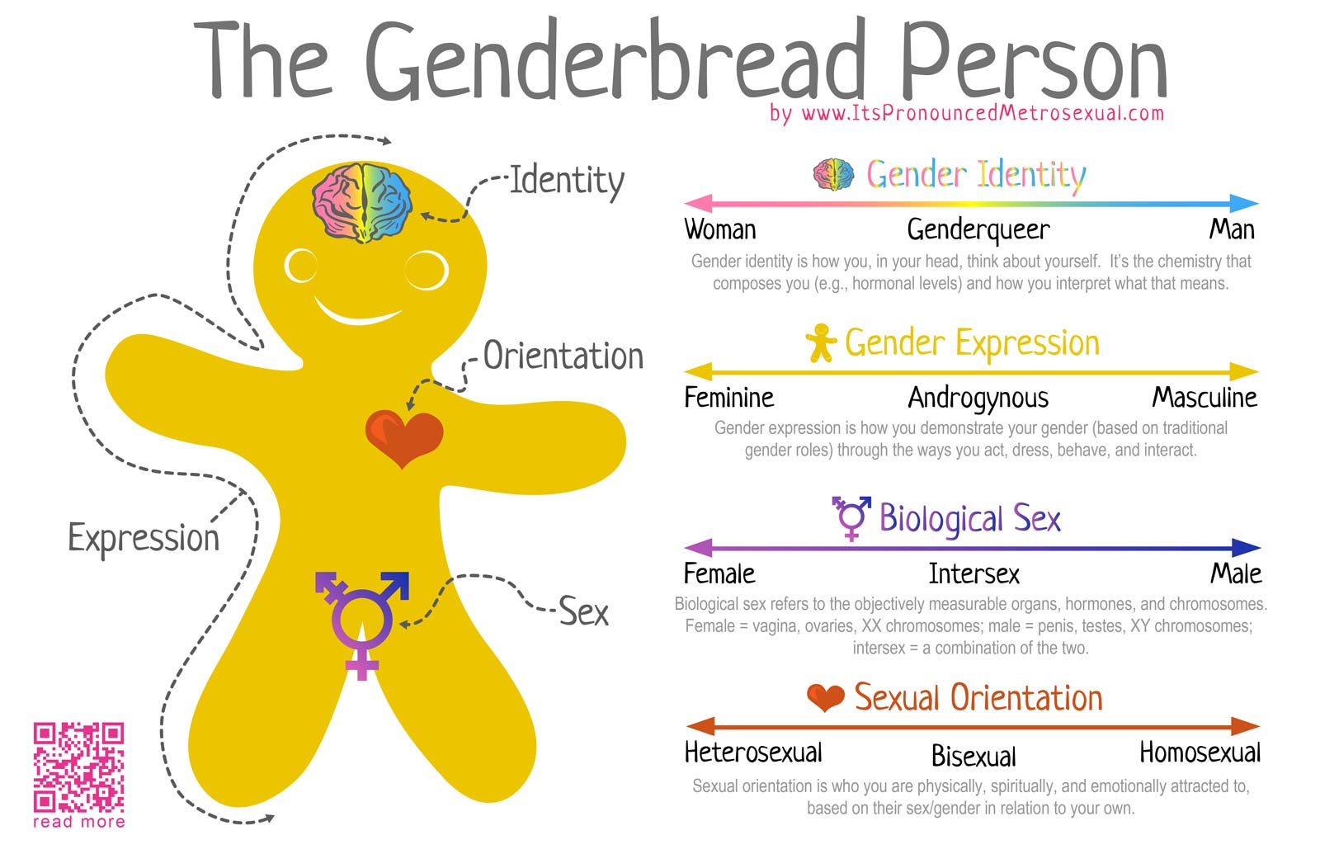

Terms to Use | Terms to Avoid | Explanation
“transgender”  “transgender boy”  “transgender girl  “trans”  “trans boy”  “trans girl” | “transgendered”  “a transgender” (n.)  “transgenders” (n.)  “transvestite”  “hermaphrodite”  “tranny”  *“ftm or mtf” (female-to-male or male-to-female) | Transgender is an adjective, not a noun. Be careful not to call someone “a transgender.” Do not add an unnecessary “-ed” to the term (“transgendered”), which connotes a condition of some kind. Never use the term “transvestite” to describe a transgender person.  The shorthand trans is often used within the LGBT+ community, but may not be understood by general audiences.  Always use a transgender person’s chosen name. Also, a person who identifies as a certain gender should be referred to using pronouns consistent with that gender. When it isn’t possible to ask what pronoun a person would prefer, use the pronoun that is consistent with the person’s appearance and gender expression.  *not derogatory to some
“gender identity”  “gender expression” | “sexual identity”  (the correct term is gender identity)  “transgender identity”  (use gender identity to refer to a person’s internal sense of gender) | Gender Identity/Expression – A person’s sense of being masculine, feminine, both or neither.  Not everyone who is transgender identifies that way; many transgender people simply identify as male or female.  Also, note that gender identity (one’s internal sense of gender) and gender expression (how a person outwardly expresses their gender) are not interchangeable terms.
“transition”  “gender confirming surgery” | “sex change”  “pre-op/post-op”  “sexual reassignment surgery”  *asking any questions relating to genitalia or bottom surgery | Transition is the accurate term that does not fixate on surgeries, which many transgender people do not or cannot undergo. Terms like “pre-op” or “post-op” unnecessarily fixate on a person’s anatomy and should be avoided.  Gender Confirming Surgery – Medical surgeries used to modify one’s body to be more congruent with one’s gender identity.  It is never appropriate to inquire about anyone’s genitalia.
“cisgender”  “cis” | “normal people”  “regular people” | Cisgender- an adjective for someone whose gender corresponds to their assigned sex  Never ostracize others by referring to cisgender people as the “normal or regular people.”
“gender queer”  “gender fluidity”  “gender neutral”  “gender variant”  “they/them/ze/hir” | “it” | -denoting or relating to a person who does not subscribe to conventional gender distinctions but identifies with neither, both, or a combination of male and female genders.  Gender Variant – A person who either by nature or by choice does not conform to gender-based expectations of society (e.g. transgender, transsexual, intersex, gender queer, etc.).  Some gender queer individuals prefer pronouns other than he/she.
“being stealth”  “being out” | *Note: It is NEVER okay to disclose someone’s gender identity, sexual orientation or intersex status. | Being Stealth – This term refers to when a person chooses to be secretive in the public sphere about their gender history, either after transitioning or while successful passing.  Being Out – May refer to the process by which one accepts one’s own sexuality or gender identity (to “come out” to oneself). May also refer to the process by which one shares one’s sexuality or gender identity with others (to “come out” to friends, etc.). This can be a continual, life-long process for homosexual, bisexual, transgender, and intersex individuals.

Statistics Do Not Lie:
41% of transgender people attempt to take their life.

In a 2011 National Transgender Discrimination Survey:
(2011 National Transgender Discrimination Survey, See: Injustice at Every Turn: A Report of the National Transgender Discrimination Survey. Grant, J.M, Mottet, L.A., and Tanis, J. http://www.endtransdiscrimination.org/PDFs/NTDS_Report.pdf)

• Discrimination was pervasive throughout the entire sample of transgender individuals, yet the combination of anti-transgender bias and persistent, structural racism was especially devastating. People of color in general fare worse than white participants across the board, with African American transgender respondents faring worse than all others in many areas examined.

• Respondents lived in extreme poverty. Our sample was nearly four times more likely to have a household income of less than $10,000/year compared to the general population.

• A staggering 41% of respondents reported attempting suicide compared to 1.6% of the general population, with rates rising for those who lost a job due to bias (55%), were harassed/bullied in school (51%), had low household income, or were the victim of physical assault (61%) or sexual assault (64%).

As a parent, you must ask yourself:
“Am I willing to risk losing my child to suicide by being unsupportive?”
Pretending your child's gender variance is not present, or trying to hide it, will not make it go away. By suppressing your child's gender identity, you may be causing more harm than good...and often times that damage is irreversible.

As a parent, you must ask yourself:

“Are my own belief systems causing my child more anguish?

Your child is not trying to defy you by expressing his or her gender identity. You need to nurture and support the ways they express themselves in order to raise a healthy, happy child. It is understandable that one’s personal belief systems may conflict with the need to affirm someone’s gender identity, yet there is no cure for how they feel. You must evaluate the belief system that may be preventing you from hearing your child. If you are able to put aside your own preconceived notions for your child's life, your child has a greater opportunity to be a happy and healthy member of society.

Ways to Support Your Child
1. Use the child’s preferred pronouns and discuss the potential
need for a new name

- Even if it seems difficult in the beginning, you must train yourself to see your child as the gender he/she/they identify with; not the gender you feel most comfortable with. Ask your child what pronoun they would like you to use and work together to find a name that feels appropriate. Some parents feel it is still their job to choose their child's new name, while others allow their child to choose their own. This is a personal family decision and there is no right or wrong way to do this. This simple act of using the child’s desired pronoun and corresponding name may be the most important step you can take in letting them know they are heard and understood.

2. Create a supportive physical and emotional environment

- Take down any old images or photos that make your child feel uncomfortable.
- Work with all family members to make sure that everyone is respecting your child’s needs. This may be especially important in divorce situations with joint custody. A child that is affirmed in one household and not another may suffer from extreme emotional distress.
- Require respect and correct pronoun usage from all other family and friends. Mistakes will happen with the adjustment of transition, but the intention is usually very obvious. Sending out a letter/email to friends and family with your expectations of their cooperation and support is an option.
- Do not expose your child to environments or groups of people that will be condemning, which may include some religious institutions and gatherings. Understand that your child is not choosing how they identify and many religious groups feel otherwise. You may need to seek out other gathering places within your faith that are more open and accepting of your child.

3. Find appropriate allies for your journey

- A primary care physician, a gender therapist, and a pediatric endocrinologist with experience (and a good reputation within the LGBT+ community) are important people to have involved. If resources are limited, consider the option of working with providers that are willing to utilize Skype.

4. Be willing to take the extra steps necessary to help your child

- Change your child’s birth certificate and other legal documentation to match their identity.
- Allow your child access to puberty blockers and cross hormones.
- Assist them in finding the appropriate wardrobe, bathing suits, toiletries and bedroom décor to match their gender identity.
- Speak to school representatives to ensure your child will be acknowledged and treated appropriately at their place of education, especially if your child will be doing a mid-year transition. Ensure they have the proper training to handle the change (resources are available to assist with this, like GLSEN).
- Compliment, encourage, and reinforce your child to be authentic and confident in their gender identity/expression.
- Find a support group for your child, or friends they can relate to and schedule play dates or meet ups. If you can't find anything local, find your child a pen pal. Siblings also need other children they can relate to.

5. Communicate

- Talk with your child everyday about their highs, lows, and concerns. Listen to them and try to help.
- Discuss any fears they have and attempt to alleviate those concerns (ex. in the restroom, etc).
- Role-play with your child to help them feel comfortable standing up for themselves and dealing with awkward situations.

Harmful Parental Practices
1. Using incorrect pronouns or previous names.

2. Parental ridicule, denial, shame, religious condemnation, or trying to get your child to "change their mind" about their gender identity.

3. Blocking access to LGBT+ friends, activities, or resources.
4. Allowing your child to progress through puberty without medical intervention.
5. Allowing friends and family who are not supportive, to be around your child.
6. Excluding your child from certain family activities or functions, due to their gender identity.

7. Assuming your child's sexuality, just because they are transitioning.

How to Come Out to Friends, Family, and School

An email or letter (www.genderspectrum.org has many examples) can be a good way to let those around you know how to support you. Sometimes face-to-face explaining can become more difficult for you, your child, and/or the other person. If you politely hand them a letter while asking them to read it and get back to you, it can alleviate the awkwardness for everybody. This can be your opportunity to answer many of the questions that people are likely to ask and provide a list resources that people can use to help educate themselves further. If this is the approach you choose, be cautious of your tone within the letter. Words written that depict sorrow and sadness, may cause others to take a similar response. Words of acceptance, love, and understanding often prompt others to react the same. Remember that excuses and/or reasons for why this has occurred are unnecessary and that love and understanding are an expectation.

Ways to Support Yourself
- Know that many parents experience a grieving stage.

- Do your research, educate yourself, and advocate for your child, but do not let your child's trans identity become your only identity.

- Focus on the present. If you worry about the future, you won't be present for the current challenges.

- Know that you don't have all of the answers, but try to equip yourself with powerful responses.

- If you stay strong, people will sense it. If you are weak, they will sense that too.

- Believe your child can have a happy future with your support!

Resources
Parents, Families, & Friends of Lesbians & Gays (PFLAG): http://www.pflag.com/

Gay & Lesbian Alliance Against Defamation (GLAAD): http://www.glaad.org/ The

Trevor Project: http://www.thetrevorproject.org/
National Center For Lesbian Rights (NCLR): http://www.nclrights.org/:

Gay, Lesbian & Straight Education Network (GLSEN): http://www.glsen.org/

Gender Spectrum: www.genderspectrum.org
Trans Youth Family Allies (TYFA): http://www.imatyfa.org/resources/parents/

Facebook: Parents of Transgender Children

Transgender Law Center: http://transgenderlawcenter.org/

San Diego/Local

- LGBT+ Center: TransForming Families Support Group
Connor Maddocks (cmaddocks@thecentersd.org) or Monica Numez-Cham or (monica@transformingfamily.org) 619-692-2077

- Darlene Tando, LCSW (tandotherapy@me.com) 619-948-8926

- Children’s Hospital Los Angeles, Dr. Joanna Olson 323-361-5372

- Trans Family Support Services, Kathie Moehlig, http://www.transfamilysos.org/ 858-382-9156

- Rady Children’s Hospital San Diego, Dr. Maja Marikovic 858-966-4032

Books:

“The Gender Creative Child,” or “Gender Born, Gender Made,” By: Dr. Diane Ehrensaft
“The Transgender Child: A Handbook for Families and Professionals,” By: Stephanie Brill and Rachel Pepper

“Transitions of the Heart: Stories of Love, Struggle and Acceptance by Mothers of Transgender and Gender Variant Children,” By: Rachel Pepper

“Raising Ryland: Our Story of Parenting a Transgender Child With No Strings Attached,” By: Hillary Whittington

“Redefining Realness: My Path to Womanhood, Identity, Love & So Much More,” By: Janet Mock

Books For Kids:

“I Am Jazz,” By: Jessica Herthel and Jazz Jennings
“It’s Okay to be Different,” By: Todd Parr
“A Peacock Among Pigeons,” By: Tyler Curry & Illustrated By: Clarione Gutierrez

“George,” By: Alex Gino

For questions, email Charisma De Los Reyes.

